**Total oxidant/antioxidant status in jaundiced newborns before and after phototherapy**

Ali Aycicek1, Ozcan Erel

**Abstract**

Objective: To evaluate the effect of phototherapy on the oxidant and antioxidant status in the serum of full-term newborns with hyperbilirubinemia.

Method: Thirty-four full-term newborns aged 3 to 10 days undergoing phototherapy were evaluated. Serum antioxidant status was determined by total antioxidant capacity and individual antioxidant components: vitamin C, uric acid, albumin, thiol concentration, and total bilirubin. Oxidant status was assessed by total oxidant status, oxidative stress index, and individual oxidant components: malondialdehyde and lipid hydroperoxide levels.

**Results:** **Concentrations of vitamin C, uric acid, total bilirubin, and malondialdehyde were significantly lower, while total oxidant status, lipid hydroperoxide levels, and the oxidative stress index were significantly higher after phototherapy (p < 0.05).**

There were significant positive correlations between total serum bilirubin and malondialdehyde concentration (r = 0.434, p = 0.001).

Conclusions: Although malondialdehyde concentration decreased after phototherapy, phototherapy negatively affects various parts of the oxidant/antioxidant defense system in jaundiced term newborns, exposing them to potential oxidative stress.

**Introduction**

Phototherapy is the most widely used form of treatment for unconjugated hyperbilirubinemia. 1,2 Its non-invasive nature, high availability, low cost, and low incidence of side effects have led to the initial assumption that it is harmless. 3 The possibility that this may not be true has been raised in several recent publications, which have demonstrated that phototherapy is a photodynamic stress and can induce lipid peroxidation. The growing appreciation of the causal role of oxidative damage and lipid peroxidation in the development of many serious diseases in newborns has given great importance to lipid peroxidation and its possible causes. 4 Free radicals and related metabolites have received considerable attention in recent years.5 They originate primarily from oxygen and are generated in the body by various endogenous systems, exposure to different physicochemical conditions, or pathophysiological states. Free radicals can modify lipids, proteins, and DNA, having been and have been involved in oxygen-induced lung injury, intraventricular hemorrhage, retinopathy of prematurity, ischemia/reperfusion injury characterized by necrotizing enterocolitis, post-asphyxial central nervous system damage, and acute tubular necrosis6,7 Bilirubin reactions involving free radicals or toxic products of oxygen reduction are well documented: unconjugated bilirubincaptures oxygen in the singlet state with high efficiency, reacts with superoxide anions and peroxyl radicals, and serves as a reducing substrate for peroxidases in the presence of hydrogen peroxide or organic hydroperoxides. 8,9

We hypothesized that an important factor in the mechanism of oxidative stress in full-term newborns with hyperbilirubinemia who underwent phototherapy in the first days of life would be increased oxidative stress in relation to antioxidants. This imbalance would be affected by exacerbated oxidative stress, reduced antioxidant levels, or a combination of both. The objective of this study was to test the validity of this hypothesis by determining the relative roles of oxidative stress and reduced total antioxidant activity.

**Methods**

Fifty-seven full-term newborns aged 3 to 10 days, born vaginally and admitted to Sanliurfa Children's Hospital due to clinically significant indirect hyperbilirubinemia, were evaluated in this study. All infants were breastfed and had no known etiological factors for hyperbilirubinemia. Infants with severe congenital malformations, maternal diabetes, birth asphyxia, sepsis, or hemolytic hyperbilirubinemia due to blood group incompatibility (Rh or ABO); those who received intensive phototherapy; those whose serum total bilirubin level increased by more than 5 mg/dL per day or was greater than 20 mg/dL in the first 24 hours after birth; and those with signs and symptoms suggestive of severe disease were excluded from the study. Clinically important indirect hyperbilirubinemia was defined as that present in infants with a total serum bilirubin concentration greater than 13 mg/dL. 10 Nude newborns, except those wearing diapers and eye shields, were placed in an incubator with a phototherapy system consisting of six white fluorescent lamps (Philips TL 20W/54) located 40 cm above the incubator. The energy of the phototherapy unit, measured by The photometer (Light Meter VF, Minolta, Japan) corresponded to 12-16 μW/cm2/nm. All infants underwent continuous phototherapy for 48 hours, except during breastfeeding, cleaning, and sampling. This time period was chosen to allow sampling simultaneously with routine bilirubin testing, thus avoiding blood collection solely for study purposes. This study was approved by the local Ethics Committee. Informed consent was obtained from the parents for the participation of their newborns in the study.

**Analytical Methods**

Blood samples were collected from a peripheral vein to determine total bilirubin, direct bilirubin, and antioxidant and oxidant concentrations before phototherapy. A second blood sample was collected from 49 infants 48 hours later. These samples were centrifuged at 1500 x g for 10 minutes within 20 minutes of collection. Serum samples were stored at -80°C and analyzed within 2 months. Total antioxidant capacity (TAC) was determined using the Erel method, which is based on the bleaching of the characteristic color of a more stable cationic radical of 2,2'-azino-bis(3-ethylbenzothiazoline-6-sulfonic acid) (ABTS) by antioxidants. The results were expressed in mmol Trolox equivalent/L. Serum thiol (total – SH group) was measured using dithionitrobenzoic acid (DTNB)13. Vitamin C concentration was determined using the FRASC method14. Uric acid, albumin, and total bilirubin, which are individual serum antioxidants, were measured using commercial kits (Abbott). Total oxidant status Serum oxidative stress (ESF) was determined using the Erel method15, which is based on the oxidation of ferrous ions to ferric ions in the presence of various oxidative species in an acidic medium and the determination of ferric ions using xylenol orange. The results were expressed in µmol H2O2/L. The Erel CAT and EOT methods are colorimetric and automated, and the precision of this assay is excellent—less than 3%. 13,16 Serum malondialdehyde (MDA) was measured using a fluorometric method. 17,18 Serum lipid hydroperoxide concentrations were also measured using the automated xylenol-ferric orange method. 19 The ratio of EOT to CAT was considered the oxidative stress index (OSI). 20,21 To perform the calculation, the CAT unit was changed from mmol Trolox equivalent/L to µmol Trolox equivalent/L, and the EOI value was calculated as follows: EOI = [(EOT, µmol/L)/(CAT, µmol Trolox equivalent/L)/100].

**Statistical Analysis**

Statistical analysis of the data was performed using the Statistical Package for the Social Sciences, version 11.0, for Windows (SPSS, Inc.). To compare blood samples collected before and after phototherapy, the Student's t-test for paired samples was used, using a 95% confidence interval. Bivariate associations between continuous variables were determined using Pearson's correlation test. p-values ​​less than 0.05 were considered statistically significant.

**Results**

The infants' mean age was 6 ± 3 days, mean length was 50 ± 3.8 cm, mean body weight was 3.1 ± 1.4 kg, and mean head circumference was 36.2 ± 1.9 cm. Twenty-nine infants were male and 28 female. Serum antioxidant/oxidant parameters before and after phototherapy are shown in Table 1. *Serum CAT, thiol concentration, and albumin levels did not change after phototherapy.*

Table 1 - Comparison of serum oxidant and antioxidant parameters before and after phototherapy in jaundiced newborns. Data are expressed as mean ± SD

Before

phototherapy

(n = 57)

After

phototherapy

(n = 49) p*

CAT (mmol equiv. of

Trolox/L) 1.54±0.31 1.48±0.13 0.281

Total – SH group (mmol/L) 0.42±0.01 0.43±0.01 0.165

Vitamin C (mg/dL) 2.1±1.3 1.3±0.6 0.029

Uric acid (mg/dL) 5.0±2.7 3.7±1.4 0.027

Albumin (mg/dL) 3.8±0.5 3.9±0.5 0.580

Total bilirubin (µmol/L) 17.1±2.5 13.8±2.3 < 0.001

EOT (µmol equiv. of

H2O2

/L) 11.34±5.9 16.34±7.4 0.002

MDA (µmol/L) 2.46±0.36 1.98±0.33 < 0.001

Lipid hydroperoxide

(µmol H2O2

/L) 6.11±2 7.37±2.8 0.025

IEO (arbitrary unit) 0.07±0.03 0.11±0.05 0.002

CAT = total antioxidant capacity; EOT = total oxidant status; IEO =

oxidative stress index; MDA = malondialdehyde.

*T test for paired samples.

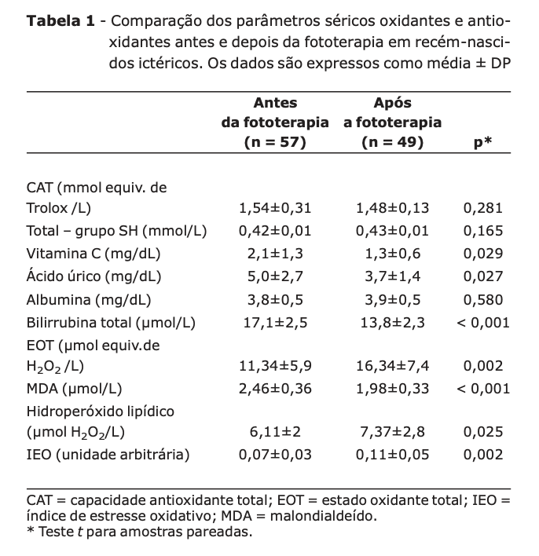

Serum concentrations of vitamin C, uric acid, total bilirubin, and MDA were significantly lower after phototherapy than before (p < 0.05). Conversely, serum levels of EOT, lipid hydroperoxide, and IEO were significantly higher after phototherapy than before (p < 0.05). There were significant positive correlations between total serum bilirubin and MDA (r = 0.434, p = 0.001).

Furthermore, there was no correlation between total bilirubin and other parameters.

**Discussion**

In the present study, concentrations of vitamin C and uric acid, which are widely known antioxidants, were significantly lower after phototherapy than before; in contrast, levels of TOS, lipid hydroperoxide, and IEO were significantly higher after phototherapy than before. Interestingly, MDA, an end product of lipid peroxidation and an oxidant marker, was low after phototherapy. There was also a significant positive correlation between MDA and total bilirubin levels. All published studies discuss the oxidative effects of phototherapy, especially lipid peroxide (a reactive substance of thiobarbituric acid), and the activities of antioxidant enzymes, but not serum total non-enzymatic antioxidant capacity. 22-27 This is the first report showing the association between these serum oxidant/antioxidant parameters in full-term infants with non-hemolytic hyperbilirubinemia undergoing phototherapy.

In a healthy human, the formation and inactivation of reactive oxygen species are balanced at a level where the compounds can exert their physiological role without any toxic effects. This balance can be unstable in the neonatal period following rapid changes in concentration,

oxygen depletion in tissues, an immature antioxidant mechanism, and considerable changes in antioxidants during neonatal development. This deterioration is particularly evident in the presence of oxidative stress, such as phototherapy. 4

.

Although phototherapy is widely used in the treatment of neonatal hyperbilirubinemia, there is concern regarding the possibility of photodynamic tissue damage. 28

.

Exposing infants to phototherapy in the presence of a sensitizer (bilirubin) resulted in oxidative damage to the erythrocyte membrane characterized by a significant increase in the concentrations of lipid peroxidation products in the membrane and hemolysis. 29 Another study reported that phototherapy in the presence of bilirubin led to a marked decrease in ATPase activity and increased susceptibility to lipid peroxidation in neonatal erythrocytes. 4.

Our study revealed that there were significant increases in serum lipid hydroperoxides and EOT

with phototherapy in jaundiced newborns. Plasma MDA concentrations in newborns with non-hemolytic jaundice were significantly higher than in healthy infants. 22,23 Ozture et al. reported that MDA concentrations decreased considerably after phototherapy compared to the period preceding it, and that there was no significant correlation between plasma MDA and bilirubin concentrations before and after phototherapy. 23 Yigit et al. reported that there was no significant correlation between MDA and bilirubin levels. 22 These authors also demonstrated that both bilirubin and MDA levels were elevated in jaundiced infants and that both parameters decreased after phototherapy. 23 However, they found no significant correlation between the opposing oxidant/antioxidant parameters. The results of our study confirmed these findings.

However, we also investigated serum levels of EOT, lipid hydroperoxide, and IEO. In

our study, serum MDA concentrations decreased considerably after phototherapy, and there was a significant correlation between plasma MDA concentrations. and bilirubin before and after phototherapy (r = 0.434, p = 0.001). These results suggest that oxidative stress

was not caused by phototherapy. However, the levels of EOT, lipid hydroperoxide, and IEO increased significantly after phototherapy. The apparent reason for these conflicting data lies in the fact that MDA determination is not a specific method for lipid peroxidation, and that it

is positively influenced by bilirubin and some aldehyde structures. 15 MDA is an end product of lipid peroxidation, and lipid hydroperoxide, which is our lipid peroxidation parameter, is an early indicator of the lipid oxidation chain, and the latter method does not interfere with other structures. Previous studies have investigated the effect of phototherapy on erythrocyte antioxidant enzyme activity (glutathione peroxidase, superoxide dismutase, etc.) in jaundiced infants. We investigated serum total antioxidant capacity, Non-enzymatic and individual antioxidants. Bohles et al. described a significant reduction in serum uric acid

during phototherapy. 30 On the one hand, the decrease in uric acid concentration is discussed as an effect of direct photodecomposition, and on the other, as an inhibitory effect of

riboflavin deficiency on uric acid formation.

We found that CAT levels were not significantly altered by phototherapy, but that vitamin C and uric acid concentrations decreased considerably. However, CAT levels were not reduced, and the oxidant/antioxidant balance shifted significantly toward the oxidant side, since other indicators of oxidant status, such as lipid hydroperoxide, EOT, and IEO levels, increased significantly in jaundiced infants undergoing phototherapy. The conclusion is that phototherapy has a negative effect on several parts of the oxidant/antioxidant system in newborns with hyperbilirubinemia, exposing them to possible oxidative stress.